­­­­

IT3122 Cloud Application Development Project (25%)

Name: Soh Wei Rong

Admin No: 191382S

Module Group: IT3122-02

In this project, you will be developing a lost-and-found website for NYP using AWS Cloud Services.

This website will display all items that have been returned to the lost-and-found department.

Part 1 – Setup and host a lost-and-found website (8%)

Create a website that allows visitors to the site to display all items that have been returned to the lost-and-found department. You should design your website to be user friendly and easy to navigate.

1. Screenshot your website – listing the various pages that you created

Scenario: The lost-and-found department is situated inside university

1. Home Page
   * Listing of the lost items
   * Search function for filtering of items

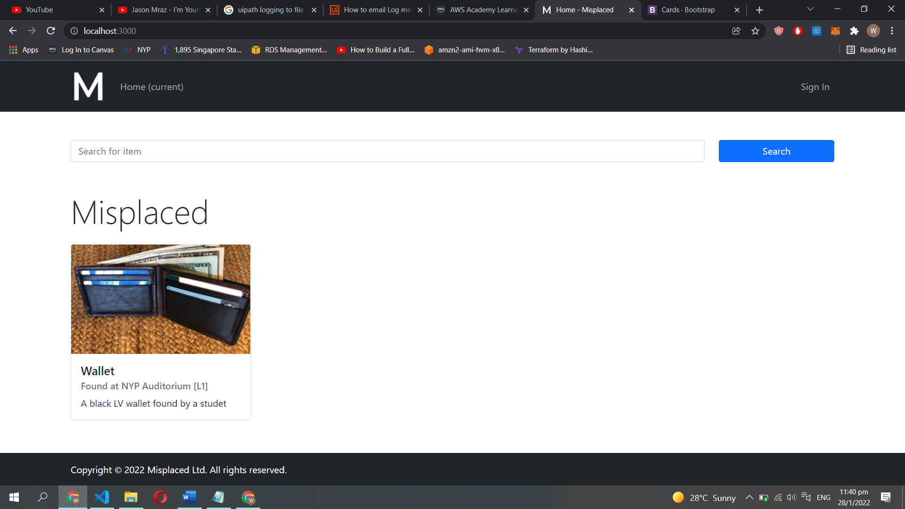

1. Report Lost Page
   * Item information such as item name and item description
   * Save the finder’s information

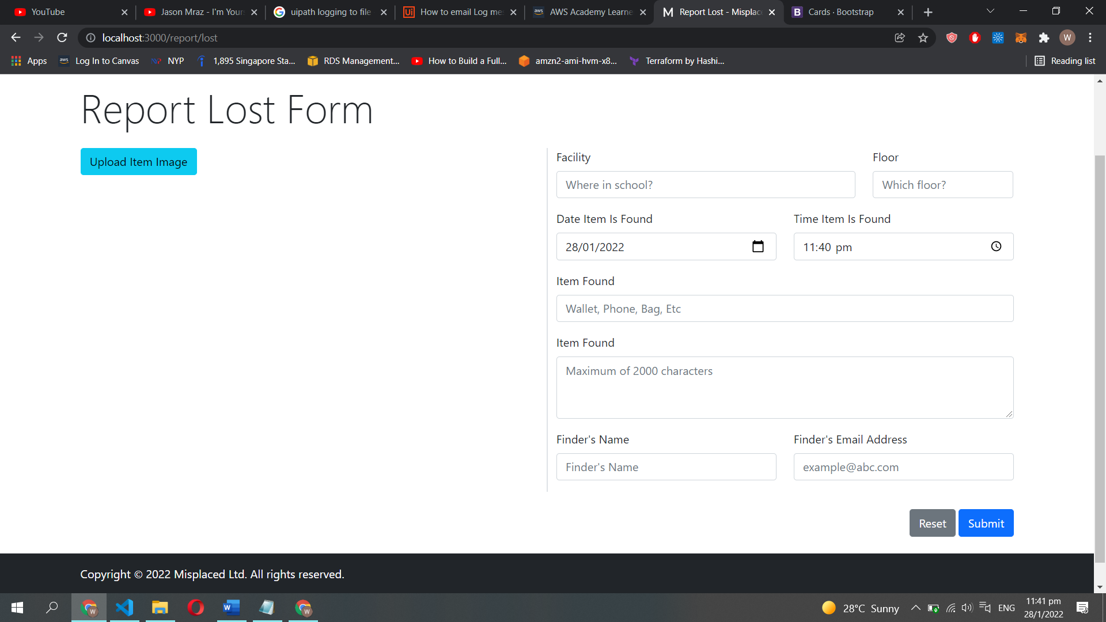

1. Report Claim Page
   * Ask for the owner information in the case of a “real owner” issue pops up

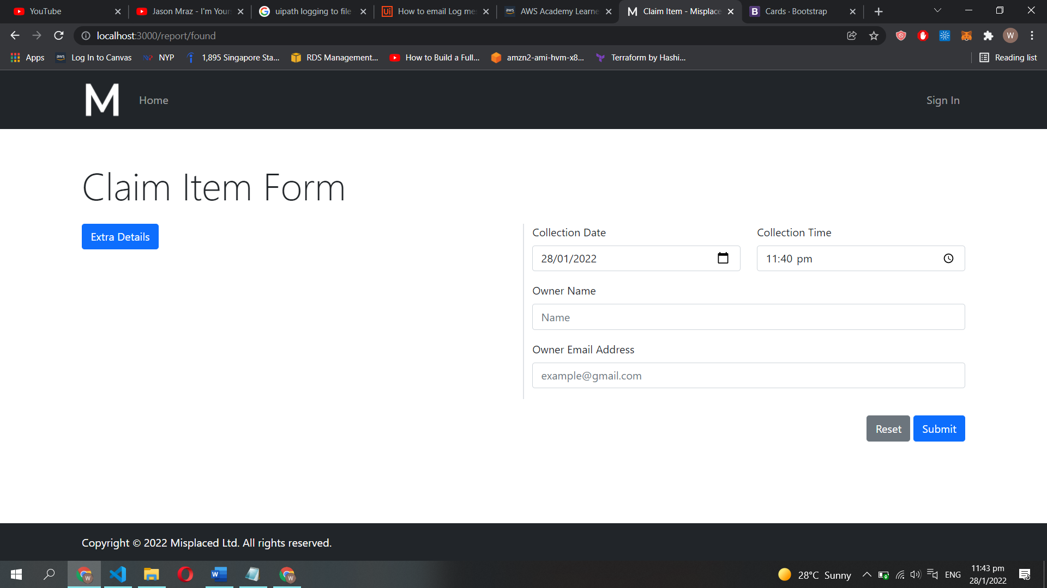

1. Sign In
   * Prevents any random user from just spamming the website with items

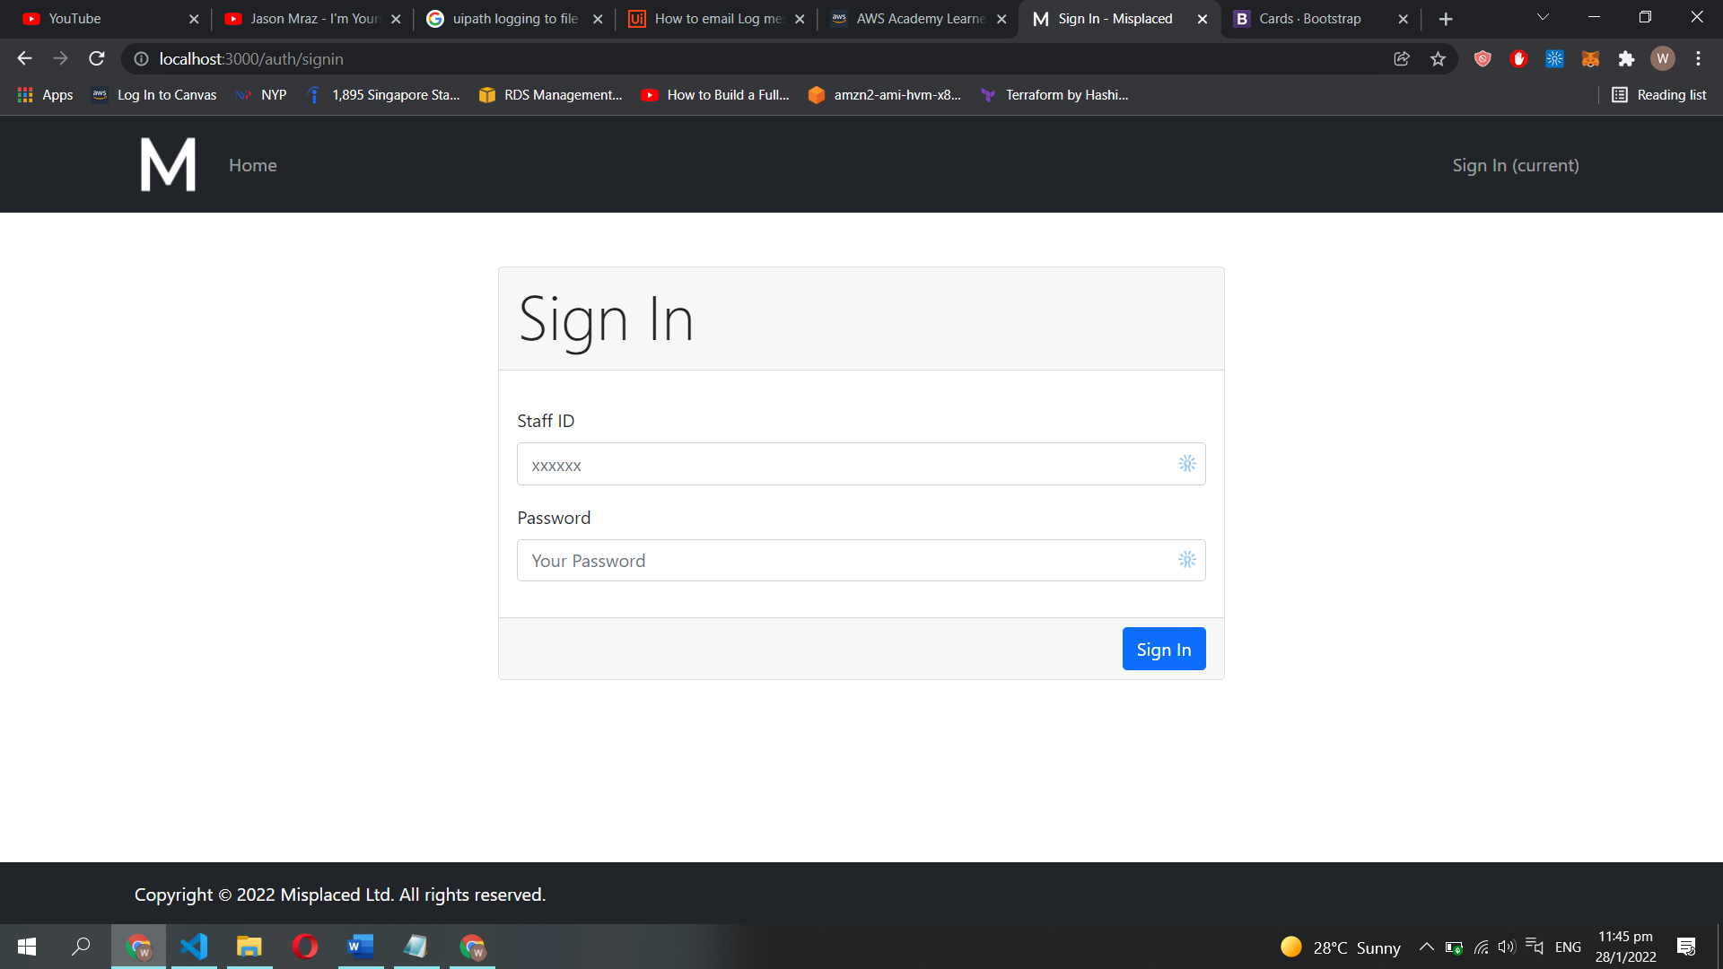

1. Zip up all the source code for website (label Part 1)

Part 2 – Upload lost items to list on website (7%)

When users find new lost items, they bring it to the lost-and-found counter and these newfound items will be added to the website.

As more and more items are found, the lost-and-found department decided to design and streamline the process.

New items can be added to the site, by uploading images of the found items with the appropriate descriptions. A database is now needed to maintain and categorize these items for easy searching and listing.

Design and develop your improved website.

1. Screenshot your website – listing the various pages that you created and showing all the features of the improved website

*<paste here>*

1. Screenshot of the database design

*<paste here>*

1. Write a brief explanation on the choice of database used and the design.
2. Zip up all the source code for website and database (label Part 2)

Part 3 (5%)

As the site grew, more and more items were found and claimed. The team decided to make it easier for users to find their lost items.

Users can create notification whenever new items are listed on the site or when an item that matched the category of item is uploaded to the site.

The team was also exploring other features to improve user experience and automation (eg using AI to recognize items etc)

Design and utilize any AWS service to achieve this feature.

1. Screenshot the setting of your improvements and the respective settings. Show evidence that these features are working.

*<paste here>*

1. Document your design and steps with the necessary descriptions and screenshots.

Part 4 (5%) – Advanced automation and features

The lost-and-found project was a great success. Other polytechnics heard about this project and have approached your team for assistance to implement a similar project.

Design, document and implement your automation plan.

Your team had other plans and ideas for enhancement and improvement to the site, these enhancements should be included

1. Document your design and steps with the necessary descriptions and screenshots for the automation process.

*<paste here>*

1. Write a brief explanation on the future enhancement plan of your lost-and-found project.

*<paste here>*

*<~The END~>*